
North Bengal International University

Lab Report: 08
Exp Name : implementation the enqueue and dequeue operation using C language.

Subject : Data Structure
Subject Code : CSE 0612-2131

Submitted By:
Name : Md. Tanvir Rahman Pranto
Dept : CSE
Roll : 0712340012101005
Semester : 2nd Year, 4th semester.

Submitted To:
Name : Saifur Rahman
Designation : Lecturer
Dept : CSE
Date :

Code:
#include <stdio.h>
#define SIZE 5

int main() {
int queue[SIZE];
int front = -1;
int rear = -1;
int choice, value, i;

while (1) {
printf("\n1. Enqueue\n");
printf("2. Dequeue\n");
printf("3. Display\n");
printf("4. Exit\n");
printf("Enter your choice: ");
scanf("%d", &choice);

if (choice == 1) {
if (rear == SIZE - 1) {
printf("Queue is full!\n");
} else {
printf("Enter value to enqueue: ");
scanf("%d", &value);
if (front == -1 && rear == -1) {
front = 0;
rear = 0;
} else {
rear = rear + 1;
}
queue[rear] = value;
printf("Enqueued: %d\n", value);
}
}

else if (choice == 2) {
if (front == -1 || front > rear) {
printf("Queue is empty!\n");
} else {
printf("Dequeued: %d\n", queue[front]);
front = front + 1;
}
}

else if (choice == 3) {
if (front == -1 || front > rear) {
printf("Queue is empty!\n");
} else {
printf("Queue elements: ");
for (i = front; i <= rear; i++) {
printf("%d ", queue[i]);
}
printf("\n");
}
}

else if (choice == 4) {
break;
}

else {
printf("Invalid choice\n");
}
}

return 0;
}

Output:

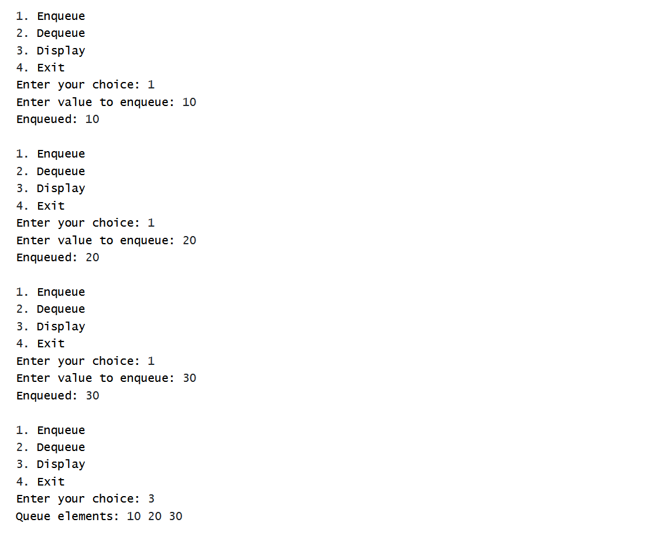

Conclusion: This lab helped me understand how a queue works using simple C code. I learned how to add (enqueue) and remove (dequeue) elements step by step using only basic logic and variables. This practice improved my understanding of data structures without using advanced techniques.

